**Time Series Data Analysis**

*By Oswin Vion Dsilva*

*240905268*

*CE*

*11*

**Objective:**

The objective of this analysis is to examine the trends, patterns, and anomalies in NVIDIA's stock prices over the given period (1st January 2023 – 27th September 2024). By applying time series analysis, we aim to:

* Identify **long-term trends** in stock performance.
* Detect **seasonal patterns** that might indicate recurring fluctuations in stock prices.
* Analyse **irregular movements** caused by external market forces or unpredictable events.

These insights will be visualized and interpreted to support informed decision-making for investors, traders, or financial analysts interested in NVIDIA's stock behaviour.

**Analysis:**

The analysis was divided into 3 main sections:

1. Exploratory Analysis

2. Data Pre – processing

3. Data visualization

**1. Exploratory Analysis:**

This section involves a surface level analysis of the data collected. The primary purpose of this section is to identify errors and outliers in the data which can then be fixed in the data pre-processing section.

The dataset was visualized in the form of a Data frame, which can be assumed to be a table of rows and columns, where the rows represent data for a particular day while the columns represent the features of the Stocks.

As we can see, the data consists of the following columns:

* Date: Represents the Date on which the Stock data was recorded.
* Open: Represents the opening price of the Stock for the day.
* High: Represents the peak value of the Stock for the day.
* Low: Represents the bottom value of the Stock for the day.
* Close: Represents the closing value of the Stock for the day.
* Adj Close: Represents the closing value of the Stock after it is adjusted for corporate actions like dividend payouts etc.
* Volume: Represents the number of Stocks traded during the day.

Next, the data set was checked to ensure that it:

* Does not contain null values
* Has proper data types for each of the columns

From the above output, we can observe that:

* The Data set does not contain any null values
* The date column is assigned the wrong data type

Next, we take a general look at the statistics of the data set to gauge a range of the values that each column has

Another important factor to consider is how the columns are related to each other. The correlation of one column with the others is displayed below:

The above heatmap shows that the Trading Volume has a bad correlation with all the other features, while the other features tend to have a good correlation amongst themselves. This would usually be the case since the prices of the next day are dependent on the prices of the previous day.

Our final check in this section is to check for outliers and/or noisy data in the data set. This is achieved by help of box plots of each column. Box plots are used to determine how much of the data falls within the various quartile ranges.

From the above box plots, it can be inferred that the data set does not contain any outliers in most of the columns.

Since, the correlation of the Volume column with the other columns is very small, it is bound to show some outliers as seen in the box plot of the Volume column.

This concludes the Exploratory analysis section. Since we identified issues with missing values and inconsistent date formats, we now refine the dataset for better accuracy in analysis.

**2. Data Pre Processing**

The primary function of this section to fix any errors or adjust outlier values that may have been detected during the exploratory analysis. This section also includes adding some new columns that may be useful to pre calculate for the Data visualization section.

This section involved the following processes:

* Assigned the proper data type to the Date column
* Created new columns Day, Month, Year, Net, and Net Change:
  + Day: Consists of the Day part of the Date.
  + Month: Consists of the Month part of the Date
  + Year: Consists of the Year part of the Date.
  + Net: Represents whether there was an increase or decrease in the value of the Stock during the day.
  + Net Change: Represents the amount of Change in value that occurred during the day.

At the end of the Data Preprocessing section, our data set looks as follows:

With the dataset cleaned and structured, we can now explore key stock trends and patterns through statistical analysis and visualizations, providing deeper insights into NVIDIA's market behaviour.

**3. Data visualization**

Once the data has been cleaned in the Data preprocessing section, we can get to the most important part of a Data Analysis: **Visualization.**

In this section, the data is represented in different ways using different types of plots and visualization. This helps us analyse different aspects of the graph such as trends, frequency etc. It may even reveal some niche details regarding the data that may not be obvious at a glance.

3.1. **How does the Daily returns of the Stock look?**

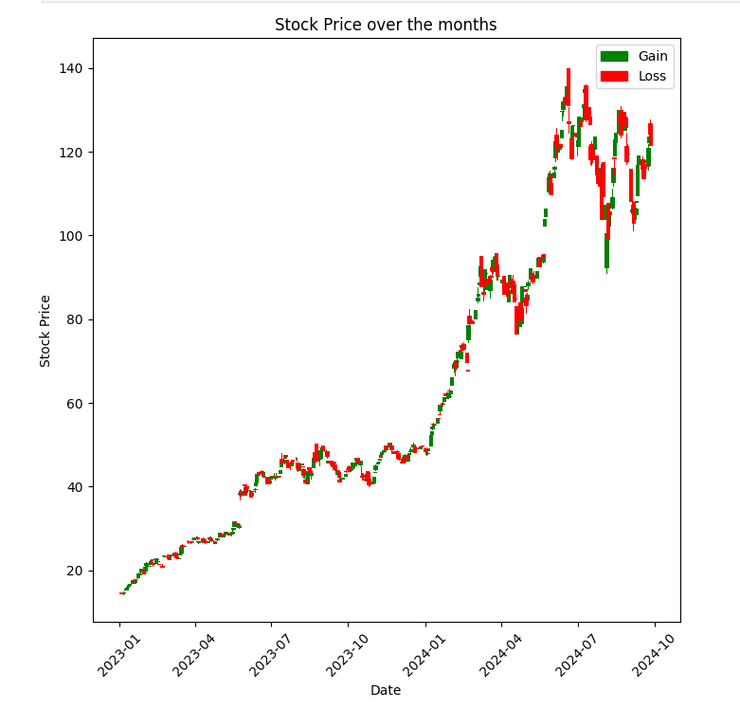

This type of graph is also known as a Candle Stick graph due to how the bars and their respective peak lines look like the body and wick of a candle.

As we can see from the graph, the Stock has seen a lot of days of Gains and Losses. However, there are breakages in the graph.

This is mainly due to 2 reasons:

1. Stock market being unavailable on those days

2. After hour/pre-market trading

A better analysis would be visualizing the month-by-month candle stick graphs for each year.

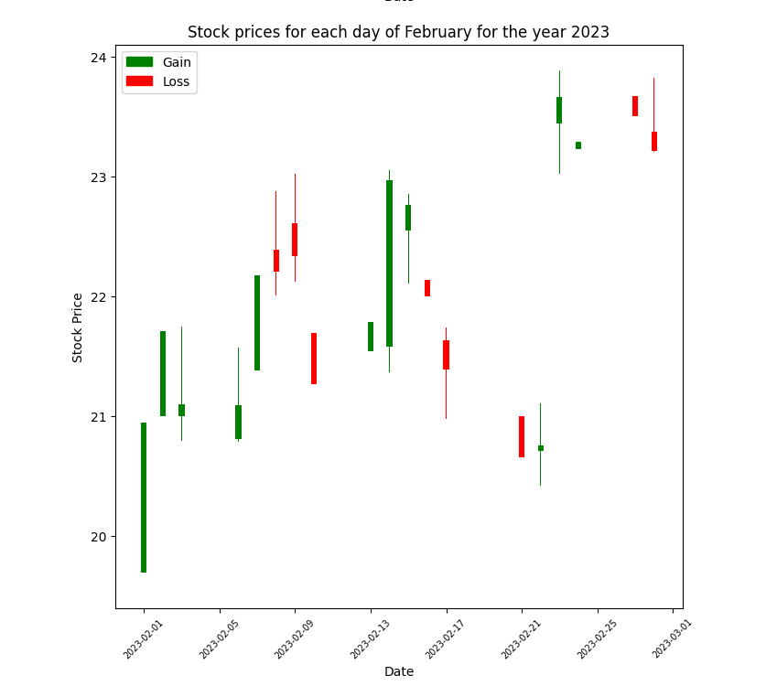

These graphs help track the value of the Stocks monthly.

They show that the stock price does, in fact, somewhat rely on the time of year and/or the months.

For instance, the stock price has primarily increased in the start of the year and towards the conclusion of the year. There is a sort of cyclical behaviour that goes up and down over the other months.

Most months have had a net rise in the stock price from the beginning to the conclusion of the month.

**3.2 Does the stock price show any repeated variation during months?**

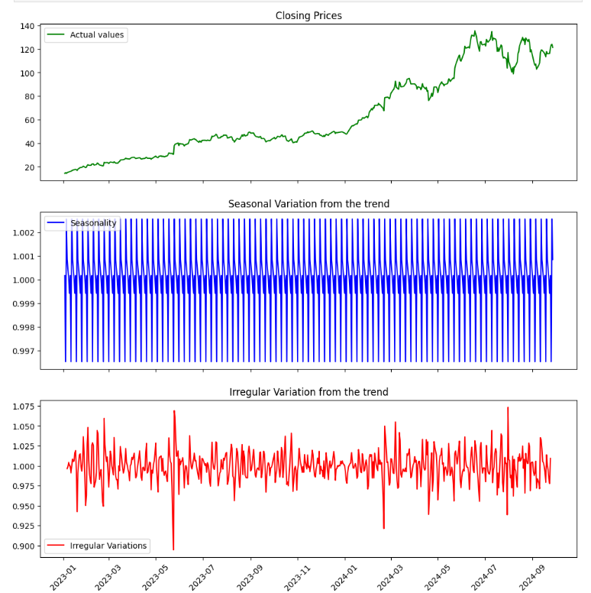

The graphs above represent the decomposition of the original time series using multiplicative decomposition. In this case, the variations are cantered around 1. Values greater than 1 indicate that the seasonal variations contribute to an increase, while values below 1 suggest that they lead to a decrease.

The time series is primarily decomposed into three main components: Seasonality, Trend, and Irregular/Random Variations.

Seasonality represents a recurring cyclic pattern that appears consistently over time. In this case, the seasonal pattern has a periodicity of approximately one-fourth of a month. While this seasonality is present in the original time series, it may be less noticeable due to the influence of irregular variations, cyclic fluctuations, or because the seasonal effect itself is relatively small. For instance, a seasonality value of 1.002 suggests that the seasonal effect contributes to a 0.2% increase in stock prices.

Irregular variations represent unpredictable patterns that occur randomly. In this case, these variations arise from the inherent uncertainty of the stock market. However, some of the larger irregularities are likely due to missing data, often caused by markets being unavailable on certain days.

**3.3 What is the Trend of the data?**

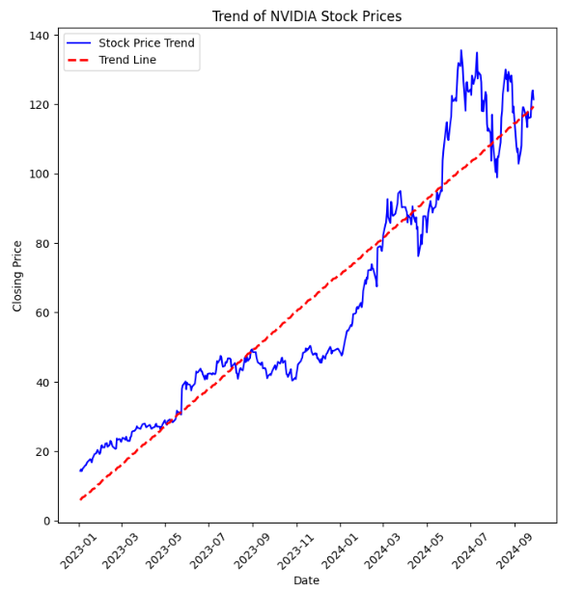

The graph above illustrates the trend in stock prices, which is one of the key components of time series decomposition.

The trend represents the overall direction of the time series. It can be increasing, indicating a general upward movement, decreasing, showing a downward trend, or flat, meaning that increases and decreases balance out over time.

The stock's consistent upward trend suggests long-term growth, making it attractive for investors seeking capital appreciation.

**3.4 What is the probability that an investor gets a positive return on his investment?**

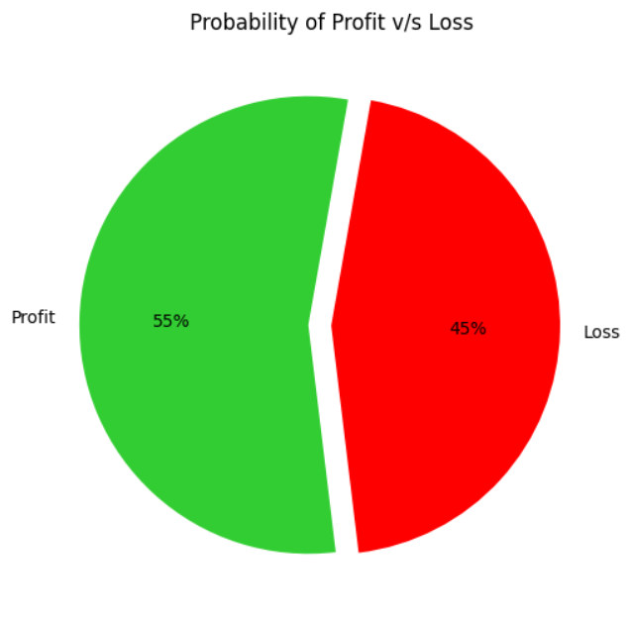

The pie chart indicates that, on average, an investor has approximately a 55% chance of earning a positive return on their investment, compared to a 45% chance of experiencing a loss based on daily stock price changes.

Looking at the trading volume can give us an idea about how and when an investor tends to maximise his trading volume, which means that it’s usually an attempt at maximising profits.

**3.5 What is the relation between Volume of Stocks and the Stock Price?**

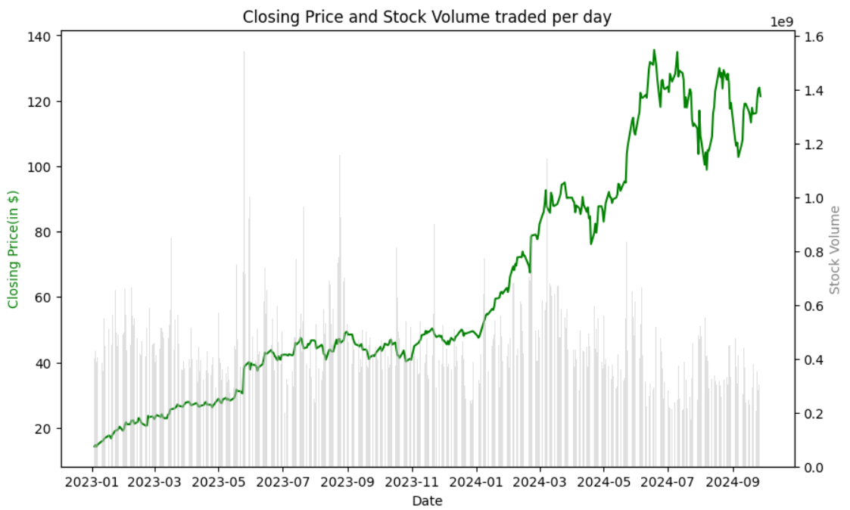

As we saw earlier from the correlation heatmap, there does not seem be to any definite relation between Stock prices and Trading volume.

However, from the graph, it can be observed that high trading volumes tend to occur in two key scenarios:

- At the end of a steep price increase, suggesting that many investors might be selling stocks to earn profits on the new increase.

- During periods of relative stability, possibly indicating that investors see a buying opportunity when prices are low and stable.

Talking about stability of the market, let’s move on to how the market tends to behave.

**3.6 Does the Daily Returns have any distribution pattern?**

The distribution of daily change percentages appears to follow a normal distribution, suggesting that the market exhibits stable and predictable price movements over time.

So far, we’ve discussed what the various trends we see in the data, how investors profit from the stocks, and about the stability of the market.

*But what about the future of the market?*

**3.7 Is there any measure to compare and/or get a look at how the future trends might look compared to the current trend?**

Moving averages are a great metric to measure current trends and compare them to future trends.

In this case, we’ve used the 50-day moving average and 200 day moving average. We can observe that the 50-day moving average is above the 200-day moving average hence it can be said that the trend would have continued to be upward. However, towards the end we can see that 50-day average has begun to take a drop. If this decline continues and the 50-day MA crosses below the 200-day MA, it could indicate the potential start of a downward trend in stock prices**.**

With all these insights available to us, let us now move on the conclusions of the report. What exactly can we do with this information?

**Conclusion:**

Our analysis from 1st January 2023 to 27th September 2024 highlights the following key findings:

* **Upward Trend** – NVIDIA’s stock has demonstrated consistent long-term growth, making it attractive for investors seeking capital appreciation.
* **Seasonal Influence** – Stock prices exhibit recurring patterns, suggesting that timing investments around seasonal trends could be beneficial.
* **Trading Volume & Price Movements** – While volume does not strongly correlate with price changes, spikes in trading activity often follow price increases, indicating potential profit-taking behaviour.
* **Investment Implications** – With a 55% probability of daily gains, long-term investors may benefit from holding NVIDIA stock, whereas short-term traders should be cautious of potential trend shifts.
* **Future Considerations** – While historical analysis provides valuable insights, future studies incorporating predictive modelling, earnings reports, and economic indicators could improve forecasting accuracy.

For long-term investors, NVIDIA’s strong growth trajectory makes it an appealing choice, but understanding trading volume spikes and trend shifts could provide a more strategic edge. Short-term traders may find opportunities by closely monitoring moving averages and price patterns to time their trades effectively.